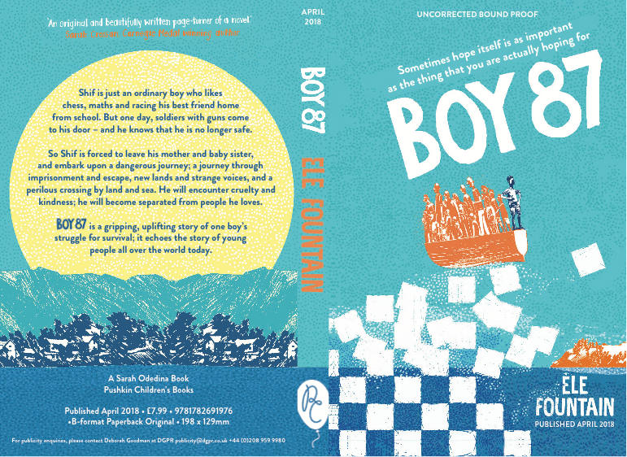

BOY 87 by Ele Fountain

‘Boy 87 is an original and beautifully written page-turner of a novel about love, survival and the strength that can be found in a hopeful human spirit.’ Sarah Crossan

Shif is an ordinary boy living with his mother and sister and next door to his best-friend Bini. The two boys share everything. They play chess together, walk to school together and are growing up together. One day their childhood comes to an abrupt end when their mothers prepare them to leave the country in the company of people smugglers to get them away from conscription in the army. But before they can begin their journey they are arrested in a ‘giffa’ and taken to a remote desert prison. Their arrival gives the long-term prisoners great hope and confronted with few choices the boys undertake a daring escape which results in only Shif making it to a distant town where a new journey begins in the company of kind fellow travellers whose help he depends on and in turn who he offers great hope to. BOY 87 is the story of one child, who could be one of many many children making that perilous journey to the Mediterranean. Opening and concluding with the same harrowing description of a storm at sea this assured debut novel humanises the headlines we see in news reports everyday and reminds us of the tough and terrible choices people have to make.

Ele Fountain is a children’s book editor with over two decades of experience of working with many much loved authors. She wrote BOY 87 after three years living in Ethiopia to shed light on the stories of the anonymous people we hear about in the news.

40,000 words, 168 pages. 8 - 12 year old middle grade reader
Publication April 2018
Ms available now
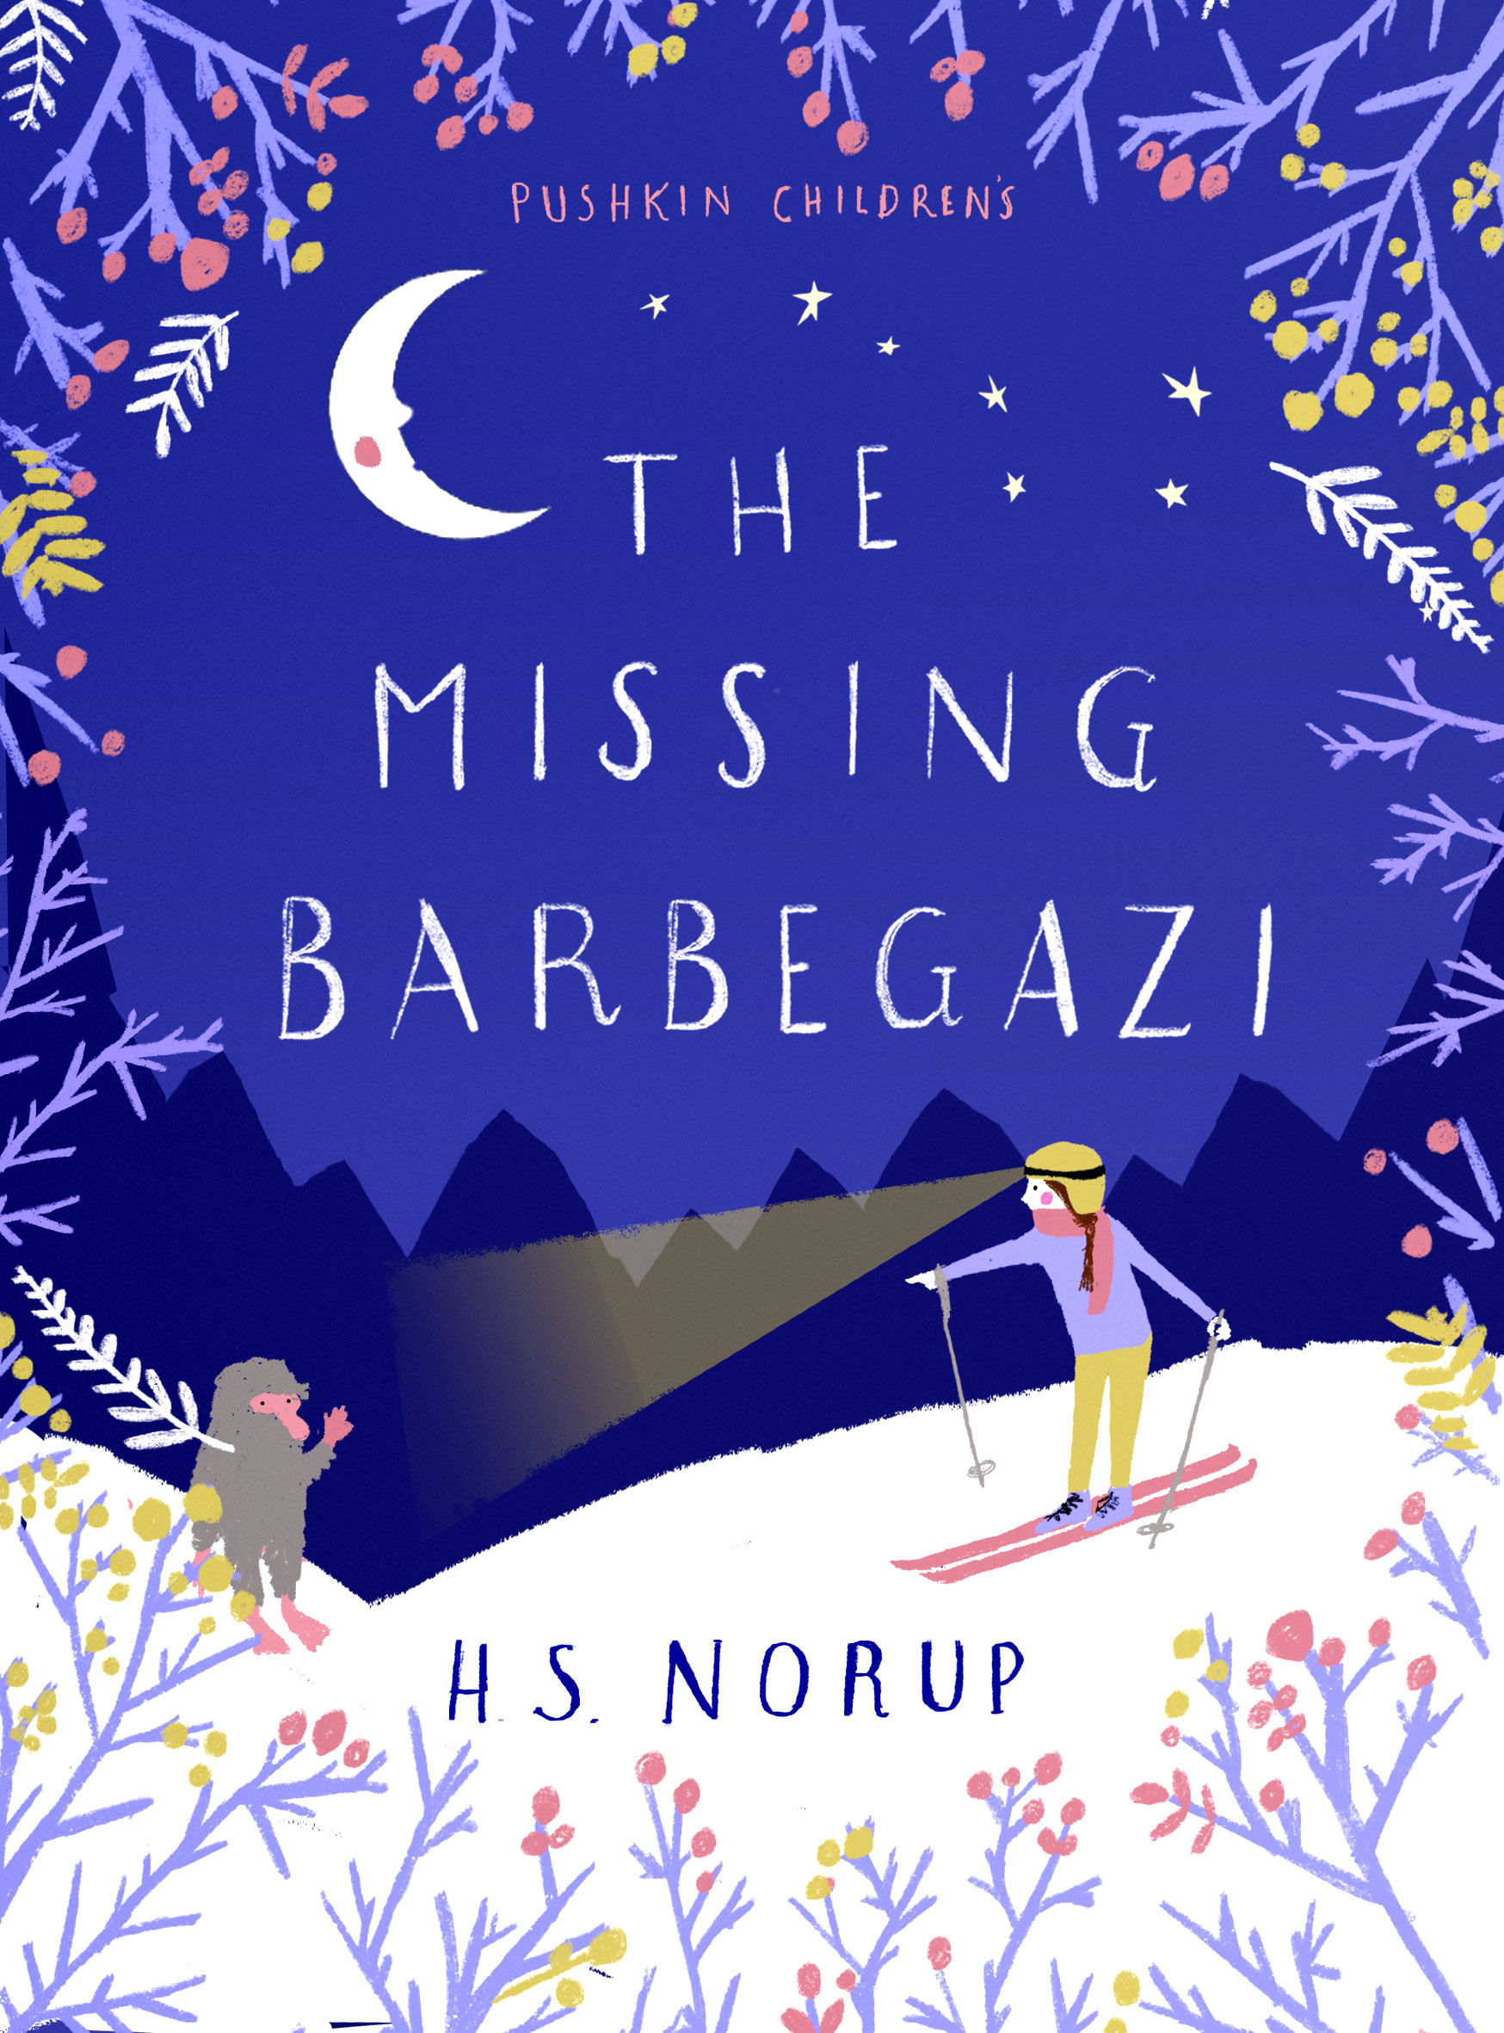

THE MISSING BARBEGAZI by Helle Norup
Tessa lives with her mother and grand-mother in a small village in the Alps. Her grand-father has recently died and she is determined to prove that the fabled Barbegazi, (small hairy fairy-folk akin to Trolls) do exist as her grand-father told her one saved him in an avalanche decades earlier. As Tessa becomes embroiled in her search her grand-mothers health begins to decline and Tessa is convinced that if she can prove to her grand-mother that Barbegazi exist she will get better. Living in a snow burrow up in the mountains a family of Barbegazi lose one of their members to a horrible trophy hunter who like Tessa is determined to prove their existence. Soon Tessa and the Barbegazi son Gawion are collaborating to rescue his sister in a nail biting race against time.
This is a wonderful adventure story of family love, friendship and trust that has all the assurance in the story-telling of Iva Ibbotson and Ellen Caldecott.

Helle Norup is a debut author who is Danish, currently lives in Singapore and is returning to live in Switzerland in the summer of 2018. She writes in English and is fluent in several other European languages. She is working on her next novel about a girl who visits the ancestral world of spirits in Singapore.

45,000 words, 168 pages. 8 - 12 year old middle grade reader
Publication September 2018
Ms available now

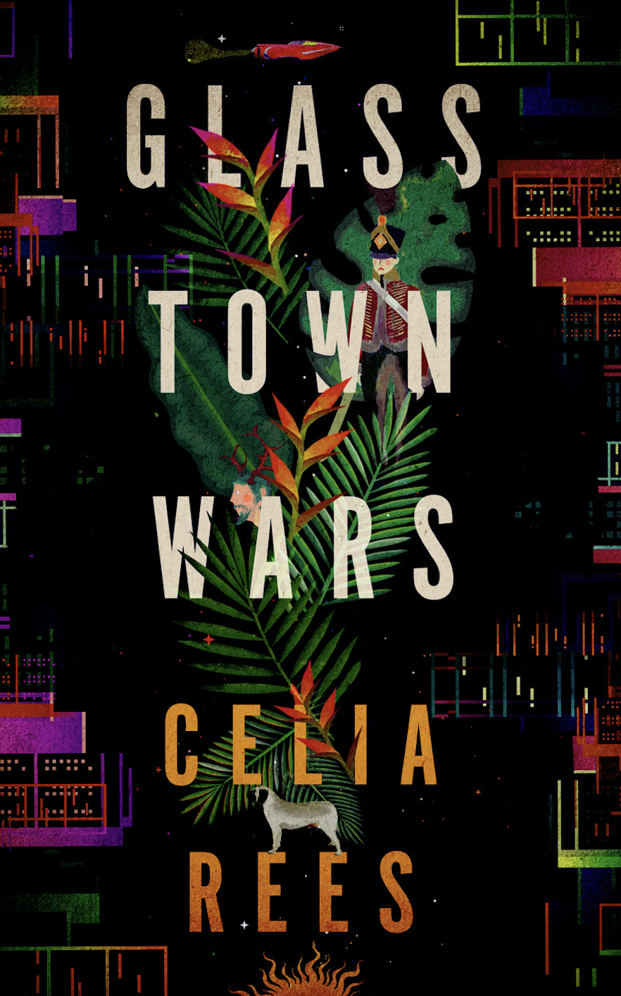
THE GLASS TOWN WARS by Celia Rees
When Tom is in hospital in a coma a very strange thing happens - he finds himself transported to another world where he meets the warrior-like Augusta who is fighting to save her kingdom against an oppressive regime. With Tom at her side she finds extra courage and Tom starts to leave his life in London behind. But life in London won't let him go so easily and his friends and family gather around him to try and bring him back, including a girl from school who he barely knows but who comes each day to his bedside to read to him from her favourite book - Wuthering Heights.

While the war escalates in Glass Town Tom’s life is held in the balance as his friend uses him as a pawn in his ambitious plans to master a virtual reality gaming world and soon Tom is unsure what is real and what is engineered as he prepares to make some difficult choices about where his allegiance, and heart, lie. An epic adventure story about stories with her trademark romance at its heart this is Celia Rees writing powerfully in a beautifully realised futuristic setting with an inspired historical context drawing on the early writings of the Bronte children.

Celia Rees is the author of many fine prize-winning best-selling books for young readers. Witch Child has been translated in to over 30 languages. She lives in Warwickshire, UK with her husband.

65,000 words, 248 pages. 12 - 15 year old teen fiction
Publication November 2018
Ms available in April 2018

THE COLLECTIVE by Lindsey Whitlock
In an imagined America, divided after a civil war along rural and urban lines, Elwyn is desperate to escape the confines of small town life in Badfish Creek. His escape takes him to stay with his Aunt and her family in the nearby town where he is ambitious to enjoy the sophistication and civilisation he feels he has been excluded from. But soon Elwyn finds himself having to make difficulty choices, choices that may mean he betrays his family and friends and all he really does hold dear.

Growing up and facing responsibilities are powerful themes in this wonderful novel as Lindsey Whitlock explores what it means to take a stand and oppose the forces of corruption and power.

Lindsey Whitlock is a debut author living in San Fransisco, California.

60,000 words, 232 pages. 12 - 15 year old teen fiction
Publication March 2019
Ms available May 2018

THE TUNNELS BELOW Nadine Wild-Palmer
A really wonderful inventive and magical quest adventure with a rather delightfully able 12 year old girl at its heart.
When Cecilia gets lost on her birthday, separated from her family on the cities underground, she has no idea of the mysterious world she is entering nor the challenges she will face to get home. But armed with her ingenuity, determination, and a marble her sister gave her as a birthday present Cecilia navigates the magical underground world, helps overcome the nasty Corvus regime and free herself and the wonderful creatures that live there. This is an exciting debut novel that shows an imaginative tour-de-force, complex and assured plotting as well as brilliantly realised characters.

Nadine Wild-Palmer is a performer, singer and writer who lives in London. This is her first novel and displays a truly inventive and inspired imagination as well as a great ability to master plot, tension and character.

40,000 words, 168 pages. 8 - 12 middle grade fiction
Publication Summer 2019. Ms available May 2018

