

RIGHTS CATALOGUE

AUTUMN 2016

Alma Books Ltd
Alma Books, 3 Castle Yard, Richmond TW10 6TF United Kingdom

For rights enquiries please contact:Elisabetta Minervini
eminervini@almabooks.com
+44 (0)20 8948 9550

Foreign Language Co-Agents
Greece Catherine Fragou, Literary Agency Iris irislit@otenet.gr

Netherlands Monique Oosterhof, Mo Literary Services mo@moliterary.nl

France Lora Fountain Literary Agency, 7 rue de Belfort, 75011 Paris, France,
lora@fountlit.com

Germany Annelie Geissler, Mohrbooks, Klosbachstrasse 110,
CH-8032 Zürich, Switzerland annelie.geissler@mohrbooks.com

Italy The Italian Literary Agency/ Marco Vigevani & Associati , Via Cappuccio, 14, 20123 Milano, Italy
claire@marcovigevani.com

Spain Agencia Literaria Carmen Balcells, Diagonal, 580, 08021 Barcelona, Spain
ma.luque@ag-balcells.com

Hungary Gynn Kalman, Torus-Books Agency, Bartok Bela u. 152/F, Budapest-1113, Hungary; gynn.kalman@gmail.com

Poland Graal, Pruszkowska 29, s 252, Warszawa 02-119, Poland, filip.wojciechowski@graal.com.pl

Romania Simona Kessler, International Copyright Agency Ltd., Str. Banul Antonache 37, 011663 Bucharest 1, ROMANIA simona@kessler-agency.ro

Bulgaria Nika Literary Agency, 11 Slaveikov Sq., BG - 1000 Sofia, Bulgaria
nika@techno-link.com

Czech Republic Kristin Olson Literary Agency, Klimentska 24, 11000 Praha 1,
kristin.olson@litag.cz

Serbia, Croatia and Slovenia Plima Literary Agency, Branka Copica 20/8,
11160 Belgrade, Serbia vuk@plimaliterary.rs

Turkey Akcali Copyright Agency, atilla@akcalicopyright.com

Korea Bookcosmos Agency, jenny@bookcosmos.com
and duran@durankim.com

Thailand Silkroad Literary Agency, 32/3 Soi Sukhumvit 31 (Soi Sawasdee), Sukhumvit Road, North Klongtan, Wattana, Bangkok 10110, Thailand jane@silkroadagency.com

Indonesia Maxima Creative Agency, Beryl Timur No.41, Gading Serpong –
Tangerang 15810 –Indonesia; santo@cbn.net.id

China Big Apple Agency, 3/F, No. 838, Zhongshan Bei Road, Zha-bei District, Shanghai 200070, PR China; cn-rights@bigapple-china.com

Brazil Karin Schindler, kschind@terra.com.br

Israel The Deborah Harris Agency, PO Box 8528, Jerusalem 91083, Israel, efrat@thedeborahharrisagency.com
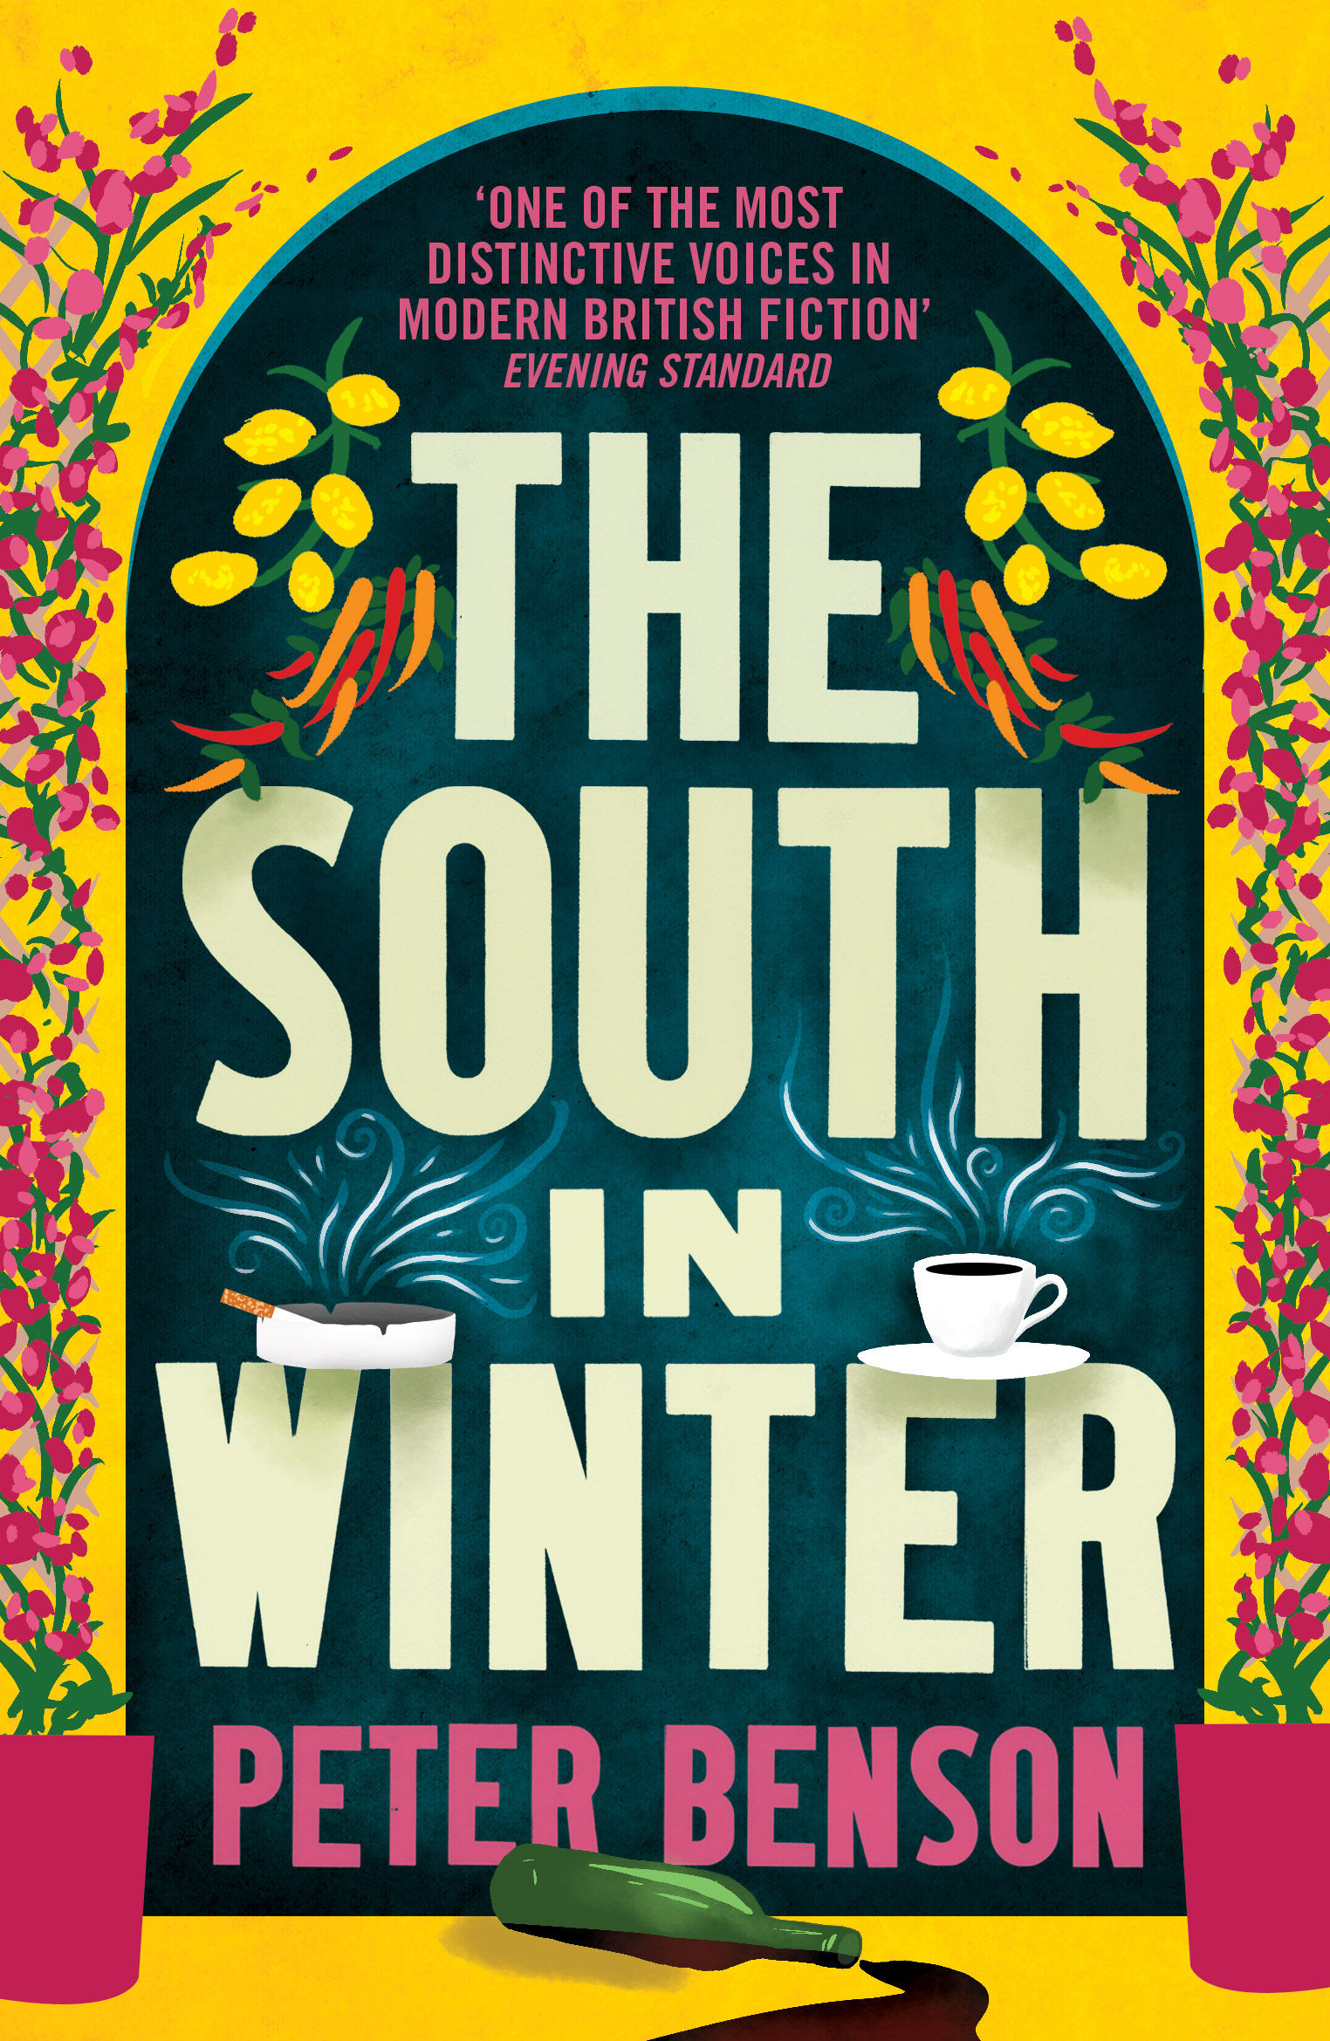

THE SOUTH IN WINTER
Peter Benson
April 2017 · 300pp

Matthew Baxter was almost there. Almost a writer, almost a lover, almost a traveller. He wrote for the Tread Lightly range of travel guides, he loved his boss and he was about to catch a plane to the south. His job was to give an out-of-season slant to the Italian guide, and he was ready. Almost. For everything wasn’t exactly as it should have been. In fact, nothing was exactly as it should have been. Especially Matthew Baxter.

Peter Benson’s new novel is a story of (almost) unrequited love and a meditation on the possibility of redemption. It’s also a tour of southern Italy, and aims to prove that although some people say “Never go back”, some people don’t know what they’re talking about.

About the Author: Peter Benson’s first novel, The Levels, won the Guardian Fiction Prize. This was followed by A Lesser Dependency, winner of the Encore Award, and The Other Occupant, which was awarded the Somerset Maugham Award. Peter Benson has also published short stories, volumes
of poetry and screenplays, some adapted for TV and radio. His works have been translated into many languages.

Other books by Peter Benson:
Two Cows and Vanful of Smoke
Isabel’s Skin
The Levels
A Lesser Dependency
The Other Occupant
Odo’s Hanging
Riptide
A Private Moon
The Shape of Clouds

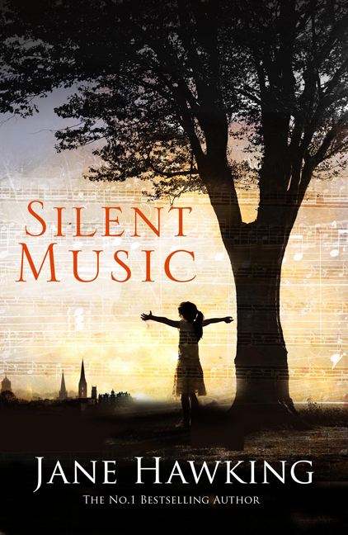

SILENT MUSIC
Jane Hawking
Septmber 2016 · 300pp

Written by the UK No.1 Bestselling author Jane Hawking, author of Travelling to Infinity: The True Story Behind the Theory of Everything
A coming-of-age novel about the unpredictable nature of human behaviour and about taking control of one’s destiny, Silent Music is a timeless portrait of post-war Britain, as well as a lyrical paean to hope and aspiration.

Growing up in London in the aftermath of the Second World War, Ruth is an observant and thoughtful child who finds herself in a confusing and mysterious adult world. She seeks refuge in her memories of her idyllic stays with her grandparents in the picturesque East Anglian countryside – which provide comforting visions of a simpler life. As she comes to terms with her surroundings and her own adolescence, Ruth finds the motivation to pursue her dream of becoming an accomplished pianist, and discovers some family secrets along the way.

ABOUT THE AUTHOR: Dr Jane Hawking, who was Stephen Hawking’s wife for over twenty
years, is a writer and lecturer. Her book At Home in France was published in 1994, followed by her memoir Travelling to Infinity which became an Oscar-winning movie in 2015 under the title The
Theory of Everything.

Rights sold for Silent Music: Spain (Lumen)

Rights sold for Travelling to Infinity: Thailand (Post Publishing); Sc Humanitas Sa (Romania); Wetbild Media (Poland); Piper Verlag (Germany); Dogan Kitapcilik (Turkey); Piemme Mondadori (Italy); Libri Könyvkiadó Kft (Hungary); PT Gramedia Pustaka Utama (Indonesia); ThinkBank (Korea); Lumen, Penguin Random House (Spain); Editora Gente (Brazil); Eksmo (Russia); Vulkan Izdavaštvo (Serbia); Albatros (Czech Republic); City Editions (France); Chongqing Publishing House Co. (China); Marcador Editora (Portugal); Gema Press (Greece); Antolog Books (Macedonia)

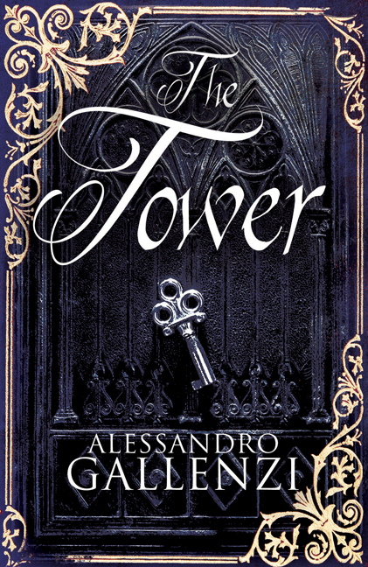

THE TOWER
Alessandro Gallenzi
Septmber 2014 · 300pp

Partly a thoroughly researched historical novel about the
Inquisition and the birth of science, partly a technological thriller dealing with the topical issues of digitization, mass control and espionage

Amman, Jordan. As an ambitious digitization project gathers pace in a vast building outside Amman, some unpublished writings by Giordano Bruno – flawed genius of the late Renaissance, renegade philosopher, occultist with a prodigious memory – disappear together with the Jesuit priest sent by the Vatican to study them.
When the priest is found dead and a series of mysterious threats ensues, it becomes clear that the stakes are high for all the parties openly or covertly involved. What dangerous ideas were contained in the stolen manuscripts? What was the ultimate secret that Bruno tried to hide from the Holy Inquisition, even as he was persecuted, imprisoned, tortured and finally burnt alive in Rome?
In this riveting, meticulously researched new novel, Alessandro Gallenzi draws on his experience as a publisher in the digital era and casts a light on the darker side of our modern technological world, while revealing how a well-kept secret can change the course of history for ever.

ABOUT THE AUTHOR: Alessandro Gallenzi is the founder of Hesperus Press, Alma Books and Alma Classics, and the successor of John Calder at the helm of Calder Publications. As well as being a literary publisher with almost ten years of experience, he is a translator, a poet, a playwright and a novelist. He wrote Bestseller in 2010 and Interrail 2012. The Tower is his third novel.

Previous Novels:
InterRail - Rights sold to: Thiele Verlag (Germany), Outdoorbooks AB (Sweden)
Bestseller - Rights sold to: Gimtasis Zodis (Liuthania), Atticus Group (Russia); Leda (Czech Republic); Alba (Spain), Outdoorbooks AB (Sweden)

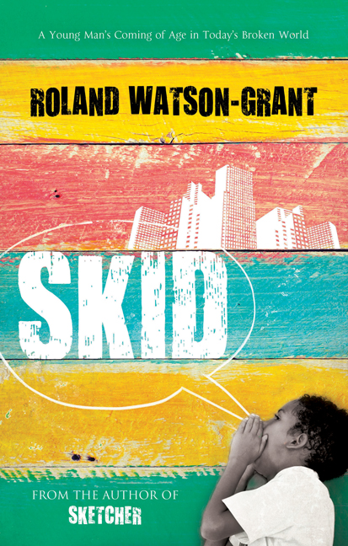

SKID
Roland Watson Grant
June 2014 · 300pp

The awaited sequel to Roland’s previous novel SKETCHER

Having left the Louisiana swamp behind, the Beaumonts are finding it hard to settle into the big city. As he unpacks the boxes after their move to Eastern New Orleans, the now sixteen-year-old Skid finds a diary which had belonged to his older brother Frico. Among various other family secrets that emerge from this discovery is the startling revelation that “Skid” is a hoodoo word of ominous significance. This throws Skid’s mind into turmoil and prompts him to launch into a quest for the real meaning of his name and the very foundations of his own being, an adventure which will pit him against his own brother and lead him to encounter Claire, a mysterious girl who seems to hold the answers to some of his questions.
Heart-warming, funny and poignant, Skid – the second volume in Roland Watson-Grant’s Trilogy of the Swamp after the critically acclaimed Sketcher – continues the exploration of a young man’s coming of age in today’s broken world.
ABOUT THE AUTHOR: Born in Kingston, Jamaica, Roland Watson-Grant, a former teacher of English, studied Literature at the University of the West Indies. He now works in advertising as Creative Director.
Praise for Sketcher

"A wonderfully joyous, eccentric first novel." The Times
"A witty Mark Twain-like diversion that tells of superstition and mojo-conjuring among the swamp folk of the Bayou during the Reaganite 1980s." The Spectator
"Part rambunctious tale of adolescence and part voodoo ghost story… a richly textured evocation of life in the Bayou, lush with fruitful descriptions and the tall tales of folklore." The Literary Review
"If the broken parts of life cannot always be mended, most of it is still more than good enough, in these rollicking chronicles from the sticky side of Louisiana." The Independent
"You can almost feel the swamp sweating off the page throughout Grant's brilliantly atmospheric and occasionally grotesque coming-of-age tale." Bath Life Magazine, Nic Bottomley (Mr B’s Emporium of Reading Delights Bookshop)
"A funny, sad, atmospheric novel... Captivating and characterful." The Sunday Times
"Funny, heartfelt and beguiling debut... The core strength of Sketcher is Skid's first-person account, told in colloquial Louisiana dialect. He is a funny and sharp observer, a bit of a wise-arse - part Scout Finch, part Huck Finn, part Bart Simpson - yet capable of stunning lyricism" The Bookseller

Rights to: Siruela (Spain)
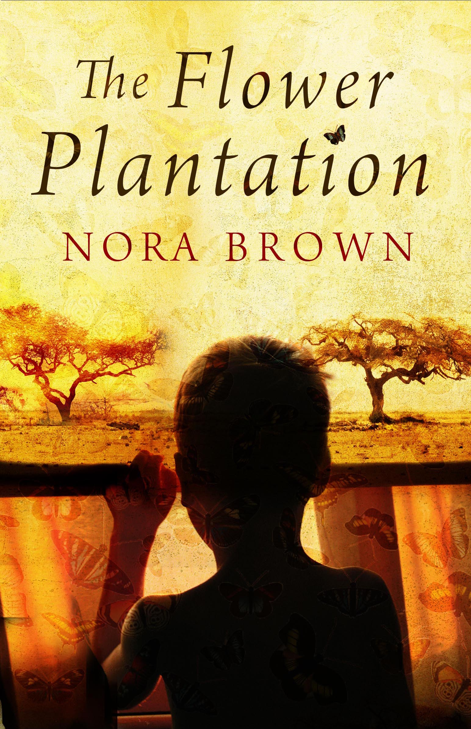

The Flower Plantation
Nora Brown

August 2013 · 300pp

Arthur Baptiste knows little of Rwanda’s past and is unaware of its emerging troubles. He lives with his parents on a flower plantation where he talks to no one, not even the butterflies he collects, until one day Beni appears.
Beni, the cook’s daughter, is a child much like Arthur but one who lives in a world far different from his own. Their friendship will take them from innocent adventures, to sexual encounters and on towards dark revelations…
When news comes that the President has been killed Arthur is forced to leave his home, the country he knows and the people he loves. Arthur must say goodbye to Beni and leave her to a fate far worse than either could have imagined.
ABOUT THE AUTHOR: Nora Brown was born in Scotland and moved to London at the age of seventeen to study composing at the Royal Academy of Music. After graduating she worked for five years as an assistant for various high-profile individuals in the music industry, before moving to Durham to become a doctor. It was at medical school that she realized her dream of becoming a writer, and she returned to Scotland to pursue her writing career. In 2010 a trip to Rwanda gave Nora the inspiration for her novel, The Flower Plantation, and her passion for Africa. Having won the Lightship First Chapter Prize with her opening chapter, she completed Creative Writing Masters at BathSpa University. Nora lives near St Andrews in Scotland with her husband. The Flower Plantation is Nora's first novel.

Remainder FICTION
Tom McCarthy, From the author of C, shortlisted for the Man Booker Prize 2010

Rights sold: Croatian (OceanMore); French (Hachette Littératures); Greek (Papyros); Italian (ISBN); Japanese (Shinchosha); Korean (Minumsa); Portuguese (Estampa); Spanish (Lengua de Trapo); Germany (Diaphanes); Uitgeverij Prometheus (Netherlands); USA (Vintage); Achuzat Bayit (Israel); Ad Marginem (Russia); Buchmann (Poland); Jaguar Kitab (Turkey)

White Man Falling FICTION
Mike Stocks

White Man Falling is a tale of domestic catastrophe, accidental crime-busting, deluded match-making and mystical absurdity set in a small town in South India.
Rights sold: Harper Collins (India), Diaphanes (Germany); Subtext (USA)

NON-FICTION - NEW

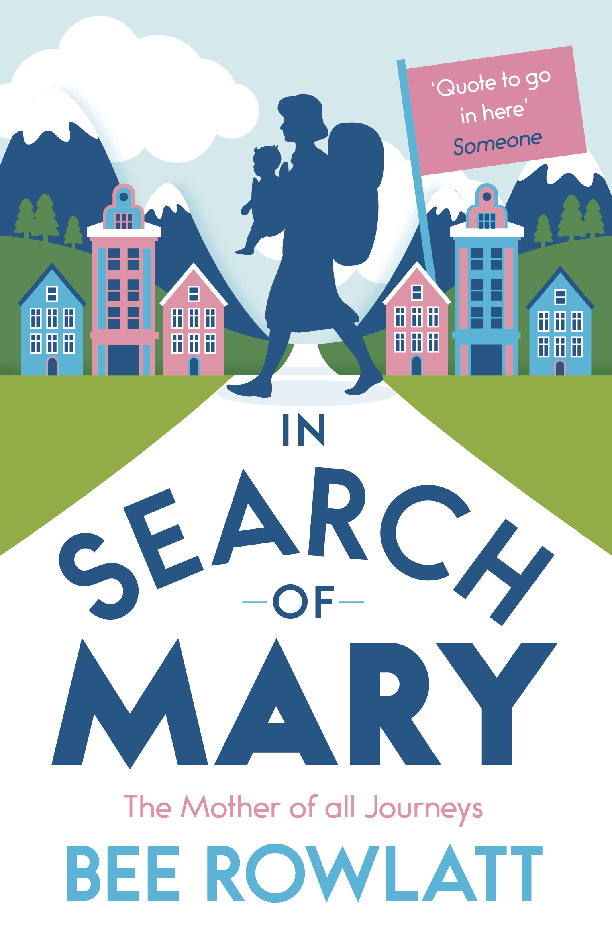

IN SEARCH OF MARY
The Mother of All Journeys

Bee Rowlatt

October 2015 · 300pp

Having been smitten by Mary Wollstonecraft’s travel book Letters Written in Sweden, Norway and Denmark in her student days, Bee Rowlatt decides to follow, with toddler in tow, in the footsteps of the world’s first celebrity feminist in order to explore the vitality of her legacy and retrace the never-dying themes of babies versus careers, comparing her encounters with guilt, progress and inequality in the eighteenth century to those experienced by women today.

On this eventful social and biographical treasure hunt they discover wild Norwegian coasts, get chased around a hostile museum in Paris and are rebirthed by naked healers in California. In her quest to chart the progress made by women across the world, Bee finds herself consulting a witch, a porn star, a very quiet Norwegian archivist and the tenants of a blighted council estate in Leeds – finding out more than what she bargained for.

ABOUT THE AUTHOR: Bee Rowlatt is a writer, journalist and broadcaster. She is a regular contributor to The Daily Telegraph and has reported for the World Service, Newsnight and BBC2. The co-author of the best-selling Talking about Jane Austen in Baghdad (Penguin 2010) as well as one of the writers featured in Virago’s 2013 anthology Fifty Shades of Feminism, Bee won the K Blundell Trust award for In Search of Mary. She has four children and
lives in London.

NON-FICTION

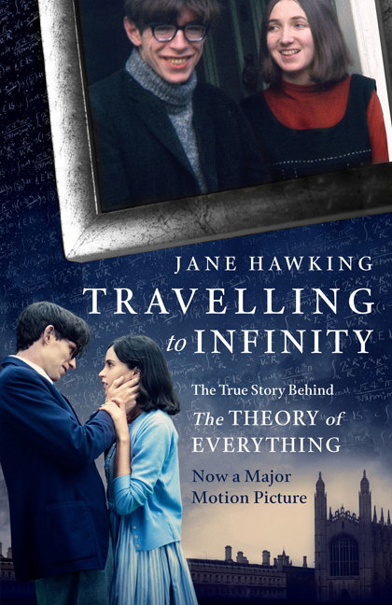

Travelling to Infinity
The True Story behind The Theory of Everything

Jane Hawking

January 2015 · 400pp

Now a major Oscar-winning Motion Picture starring Eddie Redmayne as Hawking and Felicity Jones as his wife Jane.

In this compelling memoir, Jane Hawking, Stephen Hawking’s first wife, relates the inside story of their extraordinary marriage. As Stephen’s academic renown soared, his body was collapsing under the assaults of motor neurone disease, and Jane’s candid account of trying to balance his twentyfour- hour care with the needs of their growing family will be inspirational to anyone dealing with family illness. The innerstrength of the author, and
the self-evident character and achievements of her husband, make for an incredible tale that is always presented with unflinching honesty; the author’s candour is no less evident when the marriage finally ends in a highprofile meltdown, with Stephen leaving Jane for one of his nurses, while Jane goes on to marry an old family friend.

Rights sold: Thailand (Post Publishing); Sc Humanitas Sa (Romania); Wetbild Media (Poland); Piper Verlag (Germany); Dogan Kitapcilik (Turkey); Piemme Mondadori (Italy); Libri Könyvkiadó Kft (Hungary); PT Gramedia Pustaka Utama (Indonesia); ThinkBank (Korea); Lumen, Penguin Random House (Spain); Editora Gente (Brazil); Eksmo (Russia); Vulkan Izdavaštvo (Serbia); Albatros (Czech Republic); City Editions (France); Chongqing Publishing House Co. (China); Marcador Editora (Portugal); Gema Press (Greece)

A Fine Brother: The Life of Captain Flora Sandes Non-Fiction
Louise Miller
The only woman to serve as a soldier in the First World War, the Englishwoman Flora Sandes became a hero and media sensation when she fought for the Serbian Army and pursued a distinguished career in its ranks as officer. This account charts her incredible story, from her tomboyish childhood in genteel Victorian England, her mission to Serbia as a Red Cross volunteer and subsequent military enrolment, her celebrity lecture tours of Europe, her marriage to a fellow officer and her survival of a Gestapo prison during the Second World War to her final years in Suffolk.

ABOUT THE AUTHOR: English-born (1968), largely Canadian-educated, Louise Miller has Master’s degrees in politics and law. A Fine Brother is her first book. She has been recently involved with a documentary on the subject of the work of British women in Serbia during the First World War, which was shown in February 2011 on Serbia’s RTS 2 to an audience of one million.

Combat Camera: From Auntie Beeb to the Afghan Frontline Non-Fiction
Christian Hill
Combat Camera reveals the inner workings – and absurdities – of the British military’s media operations in Afghanistan. A war memoir that draws on hundreds of field reports, it exposes the truth behind the headlines. As the pull-out date for combat troops draws closer, it will appeal to anyone who wants to know whether our campaign in Afghanistan has really been worth the effort.

ABOUT THE AUTHOR: Christian Hill joined the British Army in 1996, undertaking officer training at the Royal Military Academy Sand hurst before being posted to 3rd Regiment Royal Horse Artillery. He served as Troop Commander and later Operations Officer in Canada, Germany, Jordan, Bosnia and the Falkland Islands. After four years he left the army and retrained as a broadcast journalist, working as a showbiz reporter in London before joining the news team at BBC Radio Leicester. In 2009 he returned to soldiering as a reservist in the Media Operations Group, serving as a Combat Camera Team leader in Afghanistan in the summer of 2011.

The Duce and His Women Non-Fiction
Roberto Olla
The Duce and His Women charts the main events in Mussolini’s private and public life, from his humble beginnings in Romagna as the son of a blacksmith to his years as the director of a leading Socialist newspaper and his irresistible rise to power, with a particular focus on his renowned appetite for women, and the lesser-known influence they had on his decision-making. The result is a riveting account that will shock and haunt the readers for a long time.

ABOUT THE AUTHOR: Roberto Olla is an award-winning writer and TV journalist. He has produced a number of internationally ac- claimed history documentaries, including The Last Godfathers and Emigrants. In 2006 he has published a book called Godfathers: Lives and Crime of Mafia Mobsters (Alma Books).

Rights sold: Rizzoli (Italy)

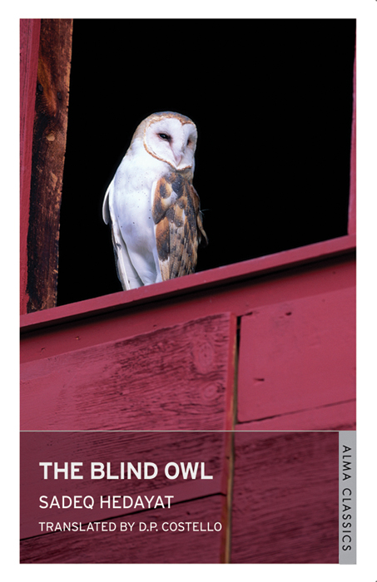

THE BLIND OWL BY SADEQ HEDAYAT
Written in Persian The Blind Owl is predominantly a love story, an unconventional love story that elicits visions and nightmare reveries from the depths of the reader’s subconscious. A young man, an old man and a beautiful young girl perform, as if framed within a Persian miniature, a ritual of destruction as gradually the narrator, and the reader, discover the meaning hidden within the dreams. This unforgettable story contains a unique blend of the mystery of the Arabian Nights and an acutely contemporary sense of panic and hallucination.

The Blind Owl was written during the oppressive latter years of Reza Shah’s rule (1925-1941). It was originally published in a limited edition in Bombay, during Hedayat’s year-long stay there in 1937, stamped with “not for sale or publication in Iran.” It first appeared in Tehran in 1941 (as a serial in the daily Iran), after Erza Shah’s abdication, and had an immediate and forceful effect.

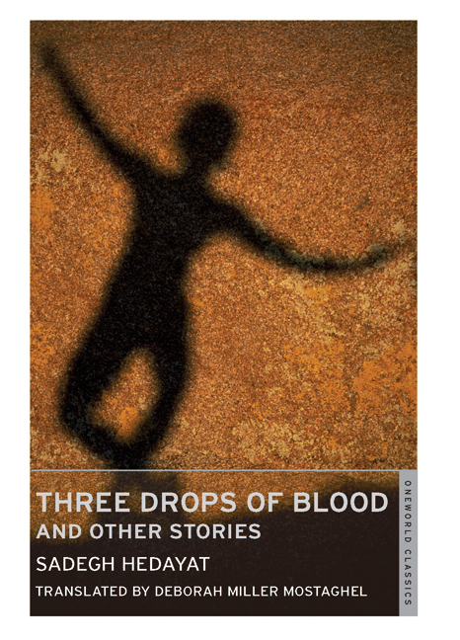
THREE DROPS OF BLOOD BY SADEQ HEDAYAT
This collection of short stories, previously unpublished in English, displays the disturbing and evocative force of Hedayat’s writing, and confirms his place in the literary canon. They depict a world of revelation, uncanny similarity, grotesquery and insanity.

The title story, ‘Three Drops of Blood’, follows the protagonist’s increasingly unstable mental state through the repeated occurence of three drops of blood, while ‘Hadji Murat’ depicts an almost Joycean epiphany in classically understated terms, as a man mistakes another woman for his wife. These are stories which, though set in a distinctive milieu, deal with universal truths and cut to the very essence of humanity.

Sadegh Hedayat was born in Teheran in 1903, of an aristocratic family, and spent most of his life there. In 1951, during a stay in Paris, Hedayat committed suicide. Recognised as the outstanding Persian writer of the century, Hedayat is generally credited with having brought his country’s language and literature into the mainstream of contemporary writing.
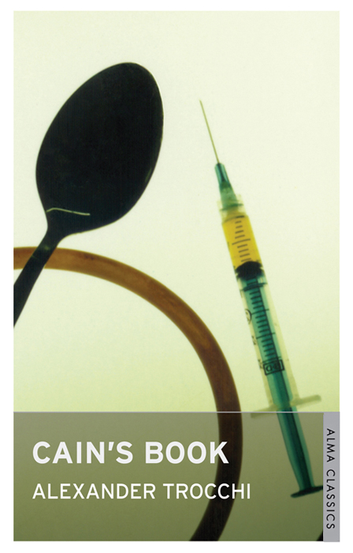
CAIN’S BOOK
Probably the most famous novel about drug addiction and the hazards and excitements of an addict’s life after Naked Lunch, this modern classic – which was prosecuted in Britain for obscenity in 1965 – still shocks in its frankness and is sadly relevant to this day.

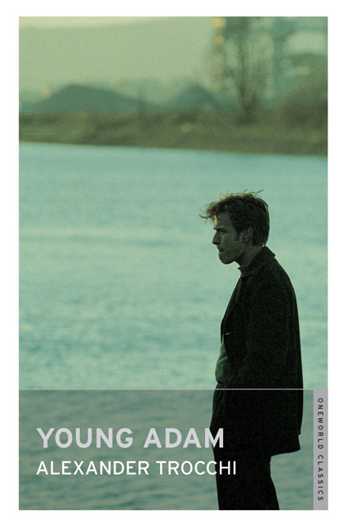
YOUNG ADAM
Trocchi’s narrator is an outsider, a drifter working for the skipper of a barge. Together they discover a young woman’s corpse floating in the canal, and tensions increase further in cramped confines with the narrator’s highly charged seduction of the skipper’s wife. Conventional morality and the objective meaning of events are stripped away in a work that proves compulsively readable.

MAN AT LEISURE
Published for the first time in 1972, this verse collection reveals lesser-known facets of the novelist Alexander Trocchi’s writing. The poems included span a long period of time, and range from the lyricism of his early love poetry and reflections on his involvement in drug culture to the penetrating comments on contemporary figures and events of his later pieces. Trocchi’s language is strong, rich and frankly obscene, and his arguments are both witty and profound.

‘Alex Trocchi has the courage so essential to a writer. He writes about spirit, flesh, and death and the vision that comes through the flesh… he has been there and brought it back’ – William S. Burroughs

“The most brilliant man I’ve ever met” – Allen Ginsberg

“The Scottish George Best of the literary world.” – Irvine Welsh

Alexander Trocchi (1925-84) was a controversial Scottish novelist of the beat generation. A heroin addict, he is best known for Cain’s Book, an autobiographical account of his sexual misadventures and drug abuse whilst living in New York.

