RIGHTS GUIDE 2015
Selected Titles

CRIME & MYSTERY… Freeman Wills Crofts; Sax Rohmer
MODERN CLASSICS… E.M. Forster; Lady Fortescue; L.P. Hartley; Rose Macaulay;
Compton Mackenzie; G.B. Stern
CHILDREN’S CLASSICS… John Masefield; Alison Uttley
ROMANCE… Catherine Gaskin; Rosamond Lehmann

For information on all titles in this guide, and for a full list of works represented by the SoA, please write to Lisa Dowdeswell: LDowdeswell@societyofauthors.org

The Society of Authors
84 Drayton Gardens
London
SW10 9SB
Tel: +44 (0)20 7373 6642
www.societyofauthors.org
CRIME & MYSTERY

 |  |  |  | FREEMAN WILLS CROFTS
Freeman Wills Crofts (1879-1957) was a railway engineer who became one of the ‘Big Five’ detective writers in the 1920s and 1930s. Best known for his ‘Inspector French’ series, four of which are now licensed to the British Library’s Crime Classics series, he was the pioneer of the ‘unbreakable alibi’ and realistic police detection, and spawned many imitators.
The Ponson Case (1921)
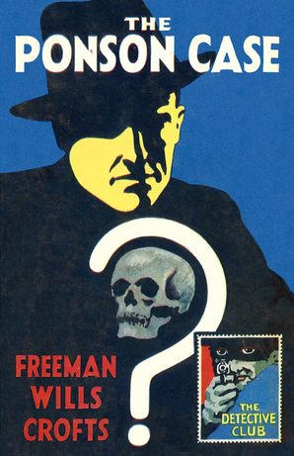 | When the body of Sir William Ponson is found in the Cranshaw River near his home of Luce Manor, it is assumed to be an accident – until the evidence points to murder. Inspector Tanner of Scotland Yard discovers that those who would benefit most from Sir William’s death seem to have unbreakable alibis, and a mysterious fifth man whose footprints were found at the crime scene is nowhere to be found…  Crofts’ second novel is soon to be re-released in HarperCollins’ The Detective Club series, which originally ran alongside its famous Crime Club list during the 1930s. The Detective Club reprinted crime classics from the late 19th and early 20th century, and featured three of Crofts’ early novels – The Ponson Case, The Pit-Prop Syndicate, and Inspector French’s Greatest Case.
This time, The Ponson Case will be released alongside The Groote-Park Murder.
UK Publisher | HarperCollins (January 2016)
All foreign rights available
Other titles currently in print include:

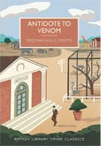
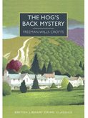
The Hog’s Back Mystery: World rights - British Library Crime Classics

Antidote to Venom: World rights - British Library Crime Classics
The Cask: All rights available excluding English language (Langtail Press), Russia (AST)
The Pit-Prop Syndicate: All rights available excluding English language (Langtail Press), Russia (AST)
Inspector French's Greatest Case: All rights available excluding English language (Langtail Press)

Fatal Venture (1939): All rights available excluding English language (Langtail Press)

For a full list of titles please contact Lisa Dowdeswell.
CRIME & MYSTERY

 |  |  | SAX ROHMER
Sax Rohmer (1883-1959) was the byline of Arthur Henry Sarsfield Ward, who pursued a career in the civil service before turning to writing. He soon became immersed in theosophy, alchemy, mysticism and the occult – reflected in his most famous creation, Dr Fu-Manchu, who has featured in radio, television, films and comic books. Rohmer was a prolific writer of novels and short stories.
“…of all of the villains populating twentieth-century imaginative landscapes, none lingers in quite the same way as Rohmer’s Dr Fu-Manchu” – Alison Wood, TLS
The Mystery of Dr Fu-Manchu (1913)
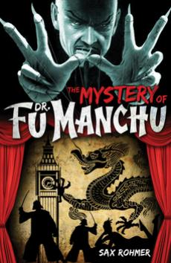 |  | London, 1913—the era of Sherlock Holmes, Dracula, and the Invisible Man. A time of shadows, secret societies, and dens filled with opium addicts. Into this world comes the most fantastic emissary of evil society has ever known… Dr. Fu Manchu.  Denis Nayland Smith pursues his quarry across continents and through the back alleys of London. As victim after victim disappears at the hands of the Devil Doctor, Smith must unravel his murderous plot before it is too late.
All fourteen Fu-Manchu novels are published in the UK and US by Titan Books. Here is a selection:
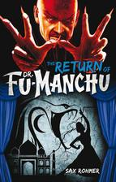
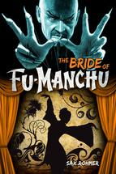
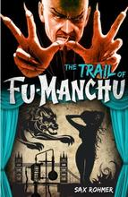
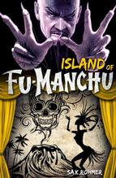
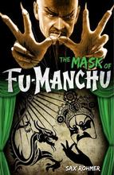
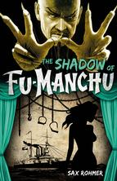

All rights available excluding English language
Other series:

Sumuru: A glamorous female supervillain, leader of secret organisation, the ‘Order of Our Lady’.
All rights available.

The Crime Magnet: Sixteen stories featuring the detective Bernard DeTreville.
All rights available excluding US (Altus Press).

Gaston Max: A Parisian criminal investigator and master of disguise, battling villainous Mr King.
All rights available.
MODERN CLASSICS

 |  |  | E.M. FORSTER
Edward Morgan Forster (1879-1970) was born in London, attended Tonbridge School and went on to King`s College, Cambridge, with which he maintained a lifelong connection. He wrote six novels, as well as essays, biographies, short stories, plays and a critical work, Aspects of the Novel, as well as the libretto for Britten`s opera Billy Budd.
A Passage to India (1924)
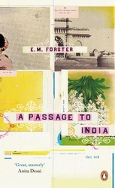 | “A Passage to India stands as a strangely timeless achievement, one of the great novels of the 20th century” – Robert McCrum  Dr Aziz is a young Muslim physician in the British Indian town of Chandrapore. One evening he comes across an English woman, Mrs Moore, in the courtyard of a local mosque; she and her younger travelling companion Adela are disappointed by claustrophobic British colonial culture and wish to see something of the 'real' India. But when Aziz kindly offers to take them on a tour of the Marabar caves with his close friend Cyril Fielding, the trip results in a shocking accusation that throws Chandrapore into a fever of racial tension.
UK Publisher | Hodder & Stoughton (hardback), Penguin Essentials (paperback)
US Publisher | W W Norton & Co.
World English language Hodder & Stoughton
Other titles currently in print:

Forster’s six well-loved novels are published by Hodder & Stoughton / Penguin in the UK. There are also collections of short stories, and works of literary criticism, travel writing, biography and collections of essays/broadcasts.

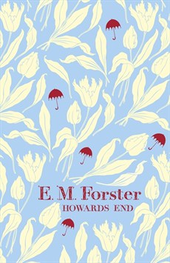
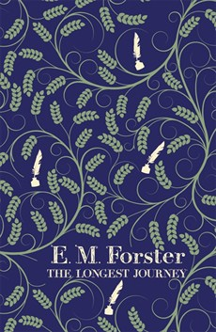
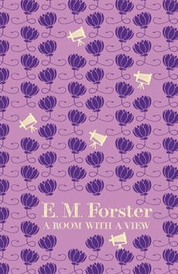  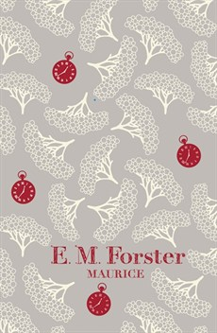 | 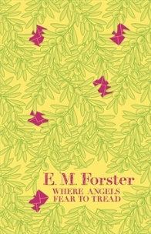  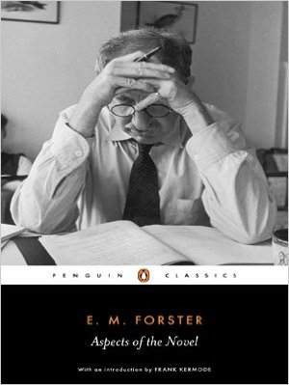
For availability of foreign rights in all titles contact Lisa Dowdeswell.

MODERN CLASSICS

 |  |  | LADY FORTESCUE
Lady Fortescue (1888-1951) Winifred Fortescue was an actress, performing in Sir Herbert Tree’s company. In 1914 she married Sir John Fortescue, the King’s Librarian and Archivist and historian of the British Army. The marriage, in spite of a huge age gap (some 28yrs), was a uniquely happy one.

Perfume from Provence (1935)
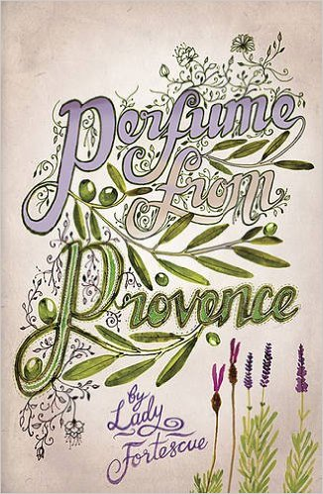 |  | In the early 1930s Winifred Fortescue and her husband, Sir John, left England and settled in Provence, in a small house amid olive groves, on the border of Grasse. Almost at once they were bewitched, by the scenery, by their garden – an incredible terraced landscape of vines, wild flowers, roses and lavender – and above all by the charming, infuriating, warm-hearted and wily Provençals.  Compulsive reading for anyone who has ever loved France, and most especially Provence.
World rights handled by Summersdale
Other titles:

Lady Fortescue wrote six further books about her adventures in Provence:

Sunset House;
There’s Rosemary, There’s Rue;
Trampled Lilies;
Mountain Madness;
Beauty for Ashes;
Laughter in Provence.

After Sir John’s death Lady Fortescue remained in the house they shared for two not altogether happy years, and then moved into a small cottage, Sunset House, which she rescued from near-dereliction. From there she watched soldiers trample past, and set about finding food and shelter for them before escaping France a little ahead of the advancing army. Back in her Sussex Cottage she re-lives the happy and adventurous holidays which she has taken in the great mountains of Southern France, and is undaunted when her Sussex home is taken over by the army. Her memoir sees her return to Provence at the end of the war, writing again of her home, her friends, and the changes she finds in the years following the war.

All rights available

MODERN CLASSICS

 |  |  | L P HARTLEY
L P Hartley (1895-1972) is the author of eighteen novels and seven short story collections. He was awarded the CBE in 1956.
The Go-Between (1953)
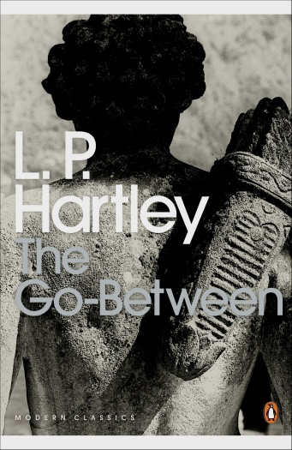 | The past is a foreign country: they do things differently there.  “Its famous formulation about the past sets the tone: this is a strange and beautiful book. I first read it in my early teens, and its atmosphere of yearning for lost times and of childish innocence challenged has haunted me ever since.” – Ian McEwan  Twelve-year-old Leo Colston spends the long hot summer of 1900 at Brandham Hall, the Norfolk estate of the family of his school-friend Marcus, and becomes an innocent accomplice in a clandestine love affair between Marcus’s beautiful older sister and a local farmer. He is drawn deeper into their dangerous game of deceit and desire, until his role brings him to a shocking revelation and the affair reaches its tragic conclusion.
This sensitive and haunting account of Leo’s premature induction into adulthood was memorably transferred to the screen by Harold Pinter and Joseph Losey in 1971, and more recently in a full-length BBC drama. The Go-Between is justly Hartley’s most celebrated work as well as being one of the best-loved of twentieth-century novels.

UK Publisher | Penguin Modern Classics
US Publisher | New York Review Books
All rights available excluding English language, Italy (Nutrimenti)
Other titles include:

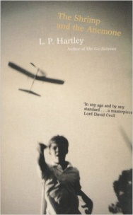 | The Shrimp and the Anemone: The first in a trilogy of novels, together known as ‘Eustace and Hilda’. Eustace is a natural hedonist, gentle, aesthetic, sociable, who lives to please and to be pleased, but is brought up in an atmosphere of puritan activity, personified by his sister, Hilda, whose aim in life is to mould him in the image of her ideal.  All rights available excluding English language (Faber)
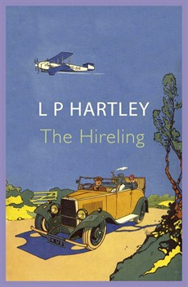 | The Hireling is the story of the relationship between a young widow, Lady Franklin and her chauffeur, Stephen Leadbitter. She is grief-stricken by the sudden loss of her husband; he proud and self-possessed. Isolated and divided by class and income, they gradually help each other awaken to the possibilities of life, but the barriers between them remain as insurmountable as ever.  All rights available excluding English language (John Murray)
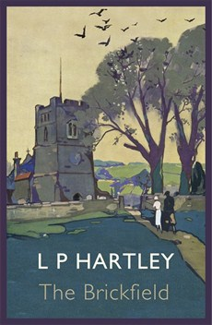  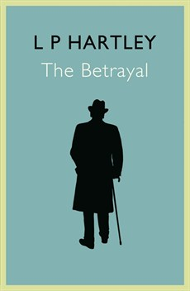 | The Brickfield & The Betrayal: Ageing novelist Richard Mardick recounts to his young secretary, Denys Aspin the story of how his solitary childhood on a lonely Fenland Farm is interrupted by a chance meeting, and an idyllic love affair with Lucy. A disused brickfield is the scene of their clandestine meeting and it is there that Lucy is discovered, drowned. Their fleeting affair is to have a shattering significance on Richard’s life, and when Denys cruelly betrays his long-kept secret we witness the unfolding of Richard’s downfall.  All rights available excluding English language (John Murray)

MODERN CLASSICS

 |  | ROSE MACAULAY
Rose Macaulay (1881-1958) In a writing career that covered the first fifty years of the twentieth century, Rose Macaulay produced twenty-three novels, six books of criticism, four books of travel and history and two collections of poetry, as well as a huge correspondence with her friends, figures such as Elizabeth Bowen, Virginia Woolf, EM Forster and TS Eliot. A great comic writer who excelled at satire, she was also an innovator and experimenter and a sharp and invigorating commentator on matters of popular and public interest.

The Towers of Trebizond (1956)
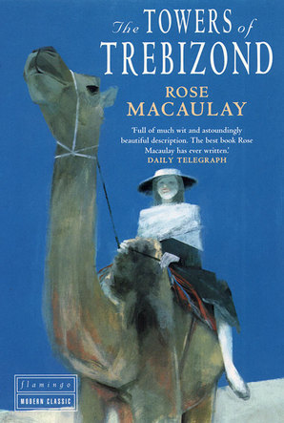 | “Take my camel, dear,” said my aunt Dot, as she climbed down from this animal on her return from High Mass.  A beautifully absurd story of the inimitable Aunt Dot, her niece Laurie and Father Chantry-Pigg – and of their expedition together to Turkey to explore the possibility of establishing a High Anglican mission there. Each member of the party has an additional extra-curricular motivation for making the trip: Father Chantry-Pigg wishes to meet the fanatics in residence at the top of Mount Ararat; Aunt Dot is set on the emancipation of Turkish women through the wider use of the bathing hat; Laurie’s object is pure pleasure.  “It is an extraordinary novel, being not just a witty and lyrically written account of the journey of a heart and soul, but also, a beguiling history lesson, a masterclass in acute social observation, and a remarkable polemic on female emancipation and religious sectarianism.” – Joanna Trollope, The Guardian
UK Publisher | HarperCollins
US Publisher | Farrar Straus & Giroux
All rights available excluding English language, Spain (Editorial Minúscula)
Other titles include:

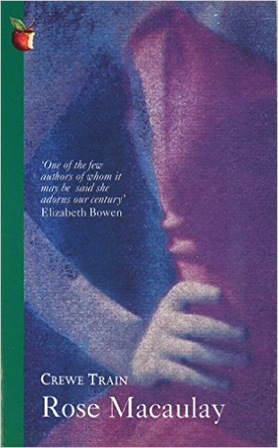 | Crewe Train: Denham Dobie has been brought up in Andorra by her father, a retired clergyman. On his death she is snatched from this reclusive life and thrown into the social whirl of London by her sophisticated relatives. Denham, however, provides a candid response to the niceties of ‘civilised’ behaviour.  Crewe Train is one of Macaulay’s wittiest satires; Denham’s reactions to the manners and modes of the highbrow circle in which she finds herself provide a devastating – and funny – social commentary as well as a moving story.  All rights available
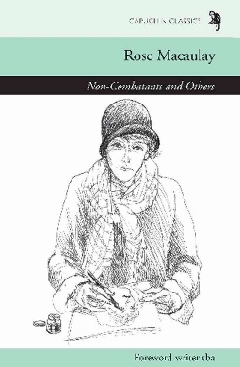 | Non-Combatants and Others: Macaulay’s powerfully-felt pacifist novel of the First World War records the suffering and passion of Alix Sandomir's rebellion against the foolishness of her fellow non-combatants. The year is 1915, and Alix moves from her cousins’ home in the country to the suburban villa Violette. Here we meet a gallery of preoccupied characters drawn with all Rose Macaulay's wit and observation. For a while Alix is distracted from the frustrations and impotence of her position, but when she learns the truth about the death of her younger brother on the front line she becomes increasingly aware of the ineffective role of women in war.  All rights available excluding English language (Capuchin Classics)
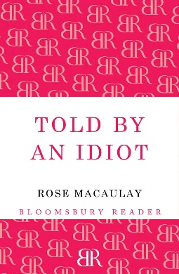 | Told by an Idiot is Macaulay’s panoramic tour de force, revealing, through the eyes of the extraordinary Garden family, the social, political and religious fortunes of England from the age of Victoria to the 1920s. There is Mr Garden, a clergyman of many denominations, about to lose his faith again, and his devoted wife. Their six children are about to be launched on the adult world: Pre-Raphaelite beauty Victoria is intent on marriage; Maurice is there, shaking his fist at the injustices of the world; Stanley does good as radical fashion dictates, and Irving is a young capitalist; Una is born for happy marriage and maternity, and detached, intelligent Rome merely watches as her family strut and fret upon the stage.  All rights available excluding English language (Bloomsbury)

MODERN CLASSICS

 |  |  |  | COMPTON MACKENZIE
Sir Compton Mackenzie (1883-1972) was born into a theatrical family. He published almost a hundred books across different genres, including fiction, history, biography, satire and memoir. He is perhaps best known for his ‘highland comedies’ Whisky Galore and Monarch of the Glen.
The Adventures of Sylvia Scarlett (1918)
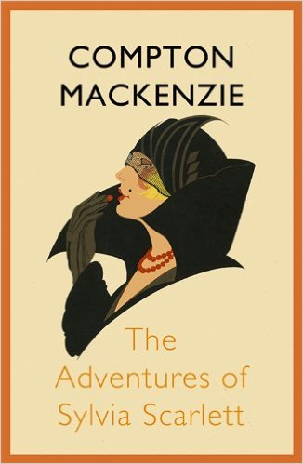 | Sylvia Scarlett, spirited and unforgettable, is Mackenzie’s own Becky Sharp, and her story features in one of the most vital and picaresque romances of the twentieth century.  We follow Sylvia’s changing fortunes from childhood to adulthood; fleeing France with her con-artist father; making an unhappy marriage to Philip, and finding escape – of sorts – in prostitution; forging a career as a singer and cabaret artiste – and finding herself trapped in war-torn Europe alongside a host of colourful bohemian characters, before finally escaping the advancing armies with Michael Fane.
UK Publisher | John Murray
All rights available excluding English language (John Murray), Italy (Edizioni Elliot)

Other titles:

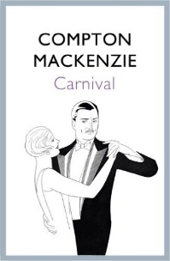 | Carnival: Jenny Pearl, a dancer, falls in love with Maurice Avery, a young dilettante who leaves her when she refuses to become his mistress. Despairingly, she falls into a loveless marriage with Trewhella, a Cornish farmer who becomes insanely jealous when Avery reappears on the scene...  Carnival and Sylvia Scarlett are two of four loosely linked novels surveying London society in the years prior to the First World War, alongside Guy and Pauline and Sinister Street.
All rights available excluding English language (John Murray)

Sinister Street: This influential epic novel is the story of Michael Fane’s upbringing and education – through public school and Oxford, to London’s underworld. Initially banned by libraries on account of its ‘perceived sexual frankness’, it nevertheless attracted the praise of Henry James, Ford Madox Ford and many others.

All rights available
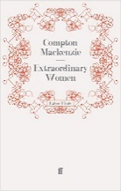
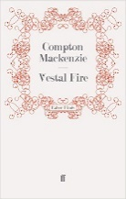
Vestal Fire & Extraordinary Women
Two borderline scandalous novels set on Capri, the ‘island of pleasure’, which Mackenzie based on the community of artists and socialites who lived there in the early years of the twentieth century.

Vestal Fire: All rights available excluding UK & Commonwealth (Faber)
Extraordinary Women: All rights available excluding UK & Commonwealth (Faber), Italy (Sonzogno)
MODERN CLASSICS

 |  |  |  | G.B. STERN
G.B. Stern (1890-1973) wrote forty novels, and was also a playwright and critic. Her literary circle included Somerset Maugham, H.G. Wells, Noel Coward and Rebecca West.
The Matriarch (1924)
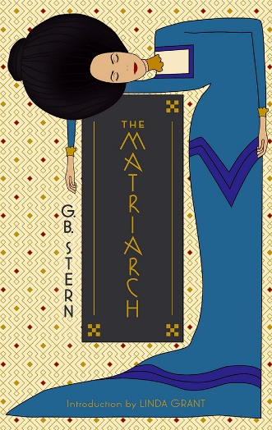 | The Rakonitz family – rich, cosmopolitan, and Jewish – is ruled over by the indomitable will of the matriarch, Anastasia. From her exotically furnished house in west London, Anastasia holds court over her children, grandchildren, and vast extended family. For someone must resolve the quarrels, celebrate the births, deaths, engagements, bankruptcies, triumphs, and explain the only way to prepare a delicious Crème Düten.  With the dawning of the twentieth century, a series of scandals and financial catastrophes strike the Rakonitzes, threatening the family ties and calling into question the legacy that binds them together.  Witty, entertaining, and full of eccentric characters, The Matriarch is the first of the ‘Rakonitz Chronicles’, a series of novels based on Stern’s own family circle.
UK Publisher | Daunt Publishing
All rights available excluding UK and Commonwealth, Italy (Sonzogno)

Further Rakonitz Chronicles

A Deputy was King (1926)
Mosaic (1930)
Shining and Free (1935)
The Young Matriarch (1942)

All rights are available

Other titles include:

Ten Days of Christmas: The war over, Clare Barnett returns from America to spend Christmas with the Maitlands. The children are excited about Uncle Ted's imminent arrival and plan a nativity play, while the "grown-ups" reflect upon Christmases past; the difficulties during the war and the happiness before, when loved ones had not been lost to them.

Dolphin Cottage: Random television interviews on street corners don’t usually have startling repercussions. But when Lucy Marriott is questioned in Brambleford one morning the consequences almost lead to tragedy. Her ‘performance’ not only interests the television producers, but also arouses the jealousy of her neighbour, would-be actress, Nonah Dysart.
UK Publisher | Corazon Books (forthcoming, 2015/2016)
All rights available excluding English language ebook & POD

CHILDREN’S CLASSICS

 |  |  | JOHN MASEFIELD
John Masefield (1878-1967) was a prolific poet and novelist, and Poet Laureate from 1930 until his death. He is remembered for his classic adventure stories for children, but above all for his sea-faring poetry anthology, Saltwater Ballads.
The Midnight Folk (1927) & The Box of Delights (1935)
“Two of the greatest children’s books ever written’”– The Times
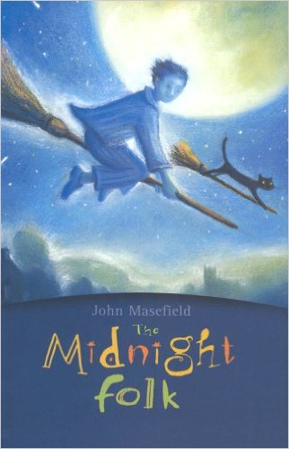 |  | Kay Harker’s great-grandfather’s treasure is lost and the evil Abner Brown is after it. He has witches and dark magic to help him, but Kay has the Midnight Folk,,,  Who will find the treasure first?  With its companion, The Box of Delights, this is a timeless adventure story, loved by adults and children alike.  “Masefield the children’s writer is unbeatable...The Midnight Folk is a truly remarkable book.” – The Daily Telegraph
UK Publisher |  | Egmont
US Publisher |  | NYRB
All rights available excluding English language
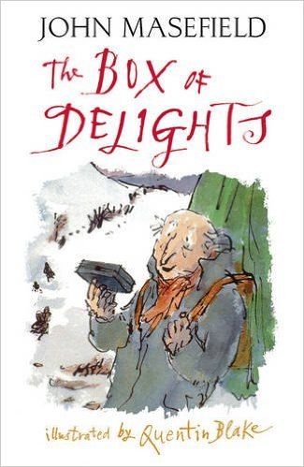 |  | And now, Master Harker, now that the Wolves are Running, perhaps you could do something to stop their Bite?  A mysterious old man has asked Kay to protect the Box of Delights, a Box with which he can travel through time. But Kay is in danger: Abner Brown will stop at nothing to get his hands on it, even kidnapping Kay’s friend Maria.  Can Kay rescue his friend, foil Abner’s plot, and save Christmas too?  ‘This book is a writer’s oft-raided treasure trove...the world’s best “crossover book”...’ — The Independent
UK Publisher |  | Egmont
US Publisher |  | NYRB
All rights available excluding English language, Korea (Sigongsa)

CHILDREN’S CLASSICS

 |  |  |  | ALISON UTTLEY
Alison Uttley (1884-1976) was a British writer of over one hundred books and was given an honorary Litt.D by Manchester University in 1970 in recognition of her literary achievements. She is now best known for her children's series featuring Little Grey Rabbit.
A Traveller in Time (1939)
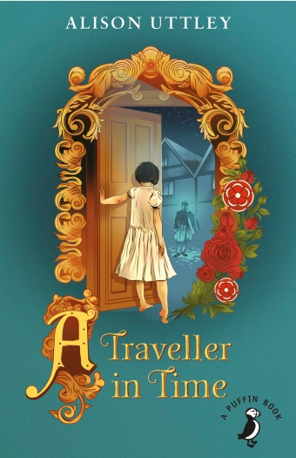 |  | “…A beautiful book...a form of enchanting ghost story”.  - The Observer  Penelope Taberner Cameron is a solitary, sickly child, and a dreamer. She is sent away from London’s dark pavements and choking fog to stay with her great aunt and uncle at their Derbyshire farm, ‘Thackers’, for some restorative country air. There, she finds hills and dales to explore, butter and cheese to churn, and hens and pigs to feed. When one day she opens an unfamiliar door, she finds herself involved in an Elizabethan adventure: the plot to liberate Mary Queen of Scots who is imprisoned nearby…  Uttley blends dream and fact to magical effect as Penelope slips back and forth between the present day and Elizabethan times, unable to change the course of events that unfold before her.
UK Publisher |  | Puffin
US Publisher |  | New York Review Books
All rights available excluding English language
Other titles include:

The Country Child

“Uttley's overpoweringly rich and detailed reminiscences about her late-Victorian childhood in a farmhouse in Derbyshire fed my very soul as surely as her lived experience did hers”
– Lucy Mangan, The Guardian

A fictional memoir of the country childhood of farmer’s daughter Susan Garland, based closely on Uttley’s own idyllic childhood in Derbyshire. It is a celebration of the sights, sounds, scents and traditions of the English countryside. Uttley brings every aspect to life, from the Christmas elderberry wine – purple, thick and sweet – to the swish of the scythes during hay-harvest.

All rights available excluding English language (Puffin, forthcoming, 2016)
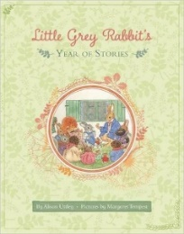
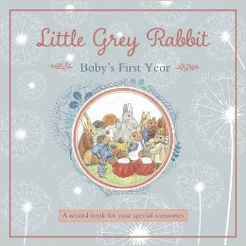
Little Grey Rabbit and Friends:
This well-loved series featuring spirited Little Grey Rabbit and her faithful friends - Fuzzypeg the Hedgehog, Wise Owl, Hare and Squirrel – is published in the UK by Templar.

World rights – Templar Publishing

ROMANCE

 |  |  |  |  |  | CATHERINE GASKIN
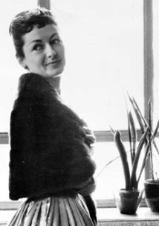
Catherine Gaskin (1929-2009): Irish by birth, Catherine moved to Australia when she was three months old. As a teenager she made the decision to write a novel, and This Other Eden, which was published when she was 17, sold 50,000 copies in its first two months. She went on to sell over 40 million copies of her books worldwide, leading her to be called "The Queen of Storytellers" and "The Girl with the Golden Pen.”

The Property of a Gentleman (1974)
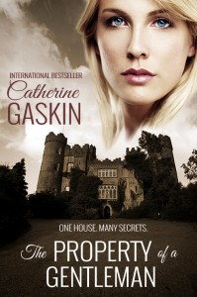 |  |  | To Joanna, bruised by the death of her exuberant mother, shaken by the reappearance of her long-lost father, the Great House amid the wild magnificence of the Lake District scenery, seemed like a fairy tale.  It was an ordinary job to evaluate the fabled contents of that house, long the closely guarded sear of the eccentric Earls of Askew. But it became a fast-moving whirlpool of love and danger which revealed to Joanne the whole truth about her family and herself.
UK Publisher |  |  | Corazon Books
All rights available excluding English language (Corazon), Germany (Fischer Verlag)
Other titles include:

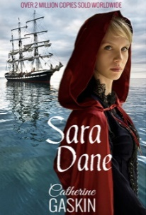 |  |  | Sara Dane: Arguably Gaskin’s best-known work. An eighteenth-century young Englishwoman is unjustly sentenced and transported to the penal colony of Australia, where she struggles to raise herself from the status of a convict to a position of wealth and power. This is a sweeping historical novel full of adventure, romance, rivalries, tragedies and triumphs.  All rights available excluding English language (Corazon), Germany (Fischer Verlag)
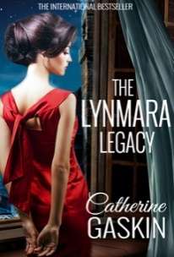 |  |  | The Lynmara Legacy: The sweeping saga of two remarkable women, their courage, ambitions, and the men they love – from New York in the Great Depression to England during the Second World War. This is a A compelling tale of passion and ambition, war and death, and the legacy of a mother’s love.  All rights available excluding English language (Corazon), Germany (Fischer Verlag)
ROMANCE

 |  |  |  |  | ROSAMOND LEHMANN
Rosamond Lehmann (1901–1990) was born on the day of Queen Victoria’s funeral, in Buckinghamshire, the second of four children. In 1927, a few years after graduating from the University of Cambridge, she published her first novel, Dusty Answer, to critical acclaim and instantaneous celebrity. Lehmann continued to write and publish between 1930 and 1976, penning works including The Weather in the Streets, The Ballad and the Source, and the short memoir The Swan in the Evening. Lehmann was made a CBE in 1982 and remains one of the most distinguished novelists of the twentieth century.
Invitation to the Waltz (1932)

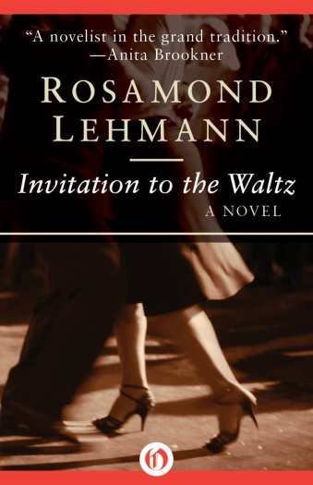 | “Lehmann perfectly captures what it is to be caught between girlhood and womanhood” – Natasha Tripney, The Guardian  “Utterly charming and so desperately true that it almost hurts” – The New York Times  Today is Olivia Curtis's seventeenth birthday. In exactly one week, she will attend her first dance. She is thrilled… and terrified.  In a home-made dress of flame-coloured silk, with a gawky, would-be curate as an escort (the only man available at such short notice), Olivia Curtis’ first dance is either going to be gloriously romantic or an agonising public humiliation. But whatever it entails it has to be an improvement on the Sheer Ordinariness of normal life.
With insight and subtlety Rosamond Lehmann explores the trepidation of a young girl’s entry into the adult world and the shadows lurking at even the most innocent of social events.

UK Publisher | Virago
US Publisher | Open Road Media
All rights available excluding UK & Commonwealth (Virago), US (Open Road Media), Germany (Fischer Verlag), Spain (Errata Naturae Editores)
Other titles include:

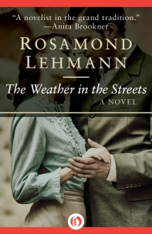 | The Weather in the Streets: A chance encounter on a train leads Olivia Curtis into an adulterous, forbidden love affair, and a new world of secret meetings, brief phone calls and snatched liaisons in anonymous hotel rooms. Controversial for its depiction of extra-marital affairs and illegal abortion, it was nevertheless an instant best-seller and remains one of Lehmann’s most enduring novels.  All rights available excluding UK & Commonwealth (Virago), US (Open Road Media), Germany (Fischer Verlag), Spain (Errata Naturae Editories)
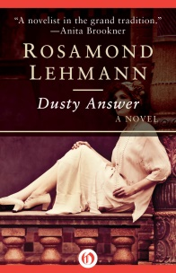 | Dusty Answer, Lehmann’s first novel, tells of Judith Earle’s sexual and emotional awakening; her loves and disillusionment at Cambridge, and above all her relationships with the Fyfes, a captivating family of cousins who make inroads into her dreams and preoccupations.  “…captures the very best of adolescence… It will consume you entirely, transforming your whole inner life for the time it takes to read.” – Jonathan Coe, The Sunday Times  All rights available excluding UK & Commonwealth (Virago), US (Open Road Media), France (Libella), Germany (Fischer Verlag), Italy (Einaudi)
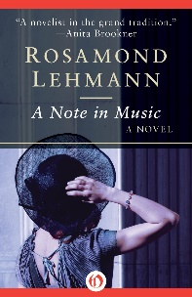 | A Note in Music: Childless and married to a dull, conventional businessman, Grace Fairfax lives a life of dreary routine and her only friend, Norah, is similarly resigned to a lifeless marriage to a cantankerous university professor. Into the dead, grey world of these two couples come charismatic visitors, Hugh Miller and his sister Clare, bringing life and colour. A Note In Music paints an often stark picture of disappointment, loneliness and failure but has an ultimately hopeful message of the vital power of love.  All rights available excluding UK & Commonwealth (Virago), US (Open Road Media), Germany (Fischer Verlag)

